**NAME- DEVANSHU SURANA**

**ELECTIVE ROLL NO-BT1-18**

**PANEL ROLL NO- PC-23**

**PRN-1032210755**

**PANEL-C**

**Assignment 4**

**Demonstrate Solidity programming of simple smart contract**

**1). Aim :** To demonstrate solidity programming of simple smart contract

**2). Objectives :**

* Develop a basic understanding of Solidity programming language.
* Create a simple smart contract using Solidity.
* Execute and deploy the Solidity smart contract on a test blockchain network for practical demonstration.

**3). Theory :**

Smart Contracts :

Solidity :

Data types in Solidity :

**4). Implementation :**

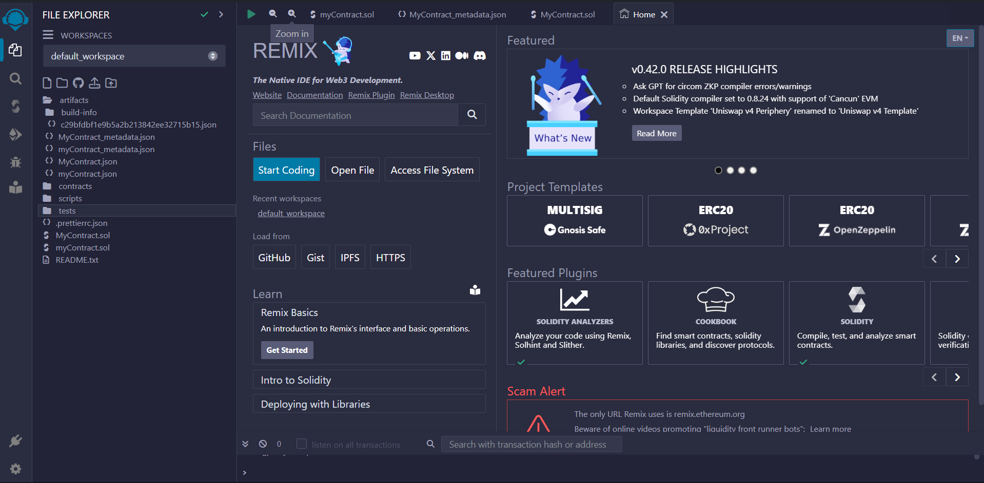

4.1). Homepage of remixIDE

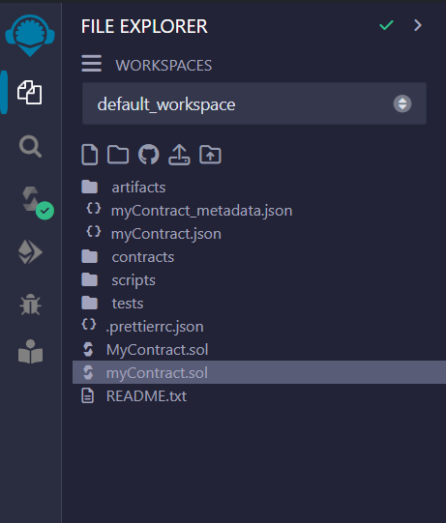

4.2). Project boilerplate or template

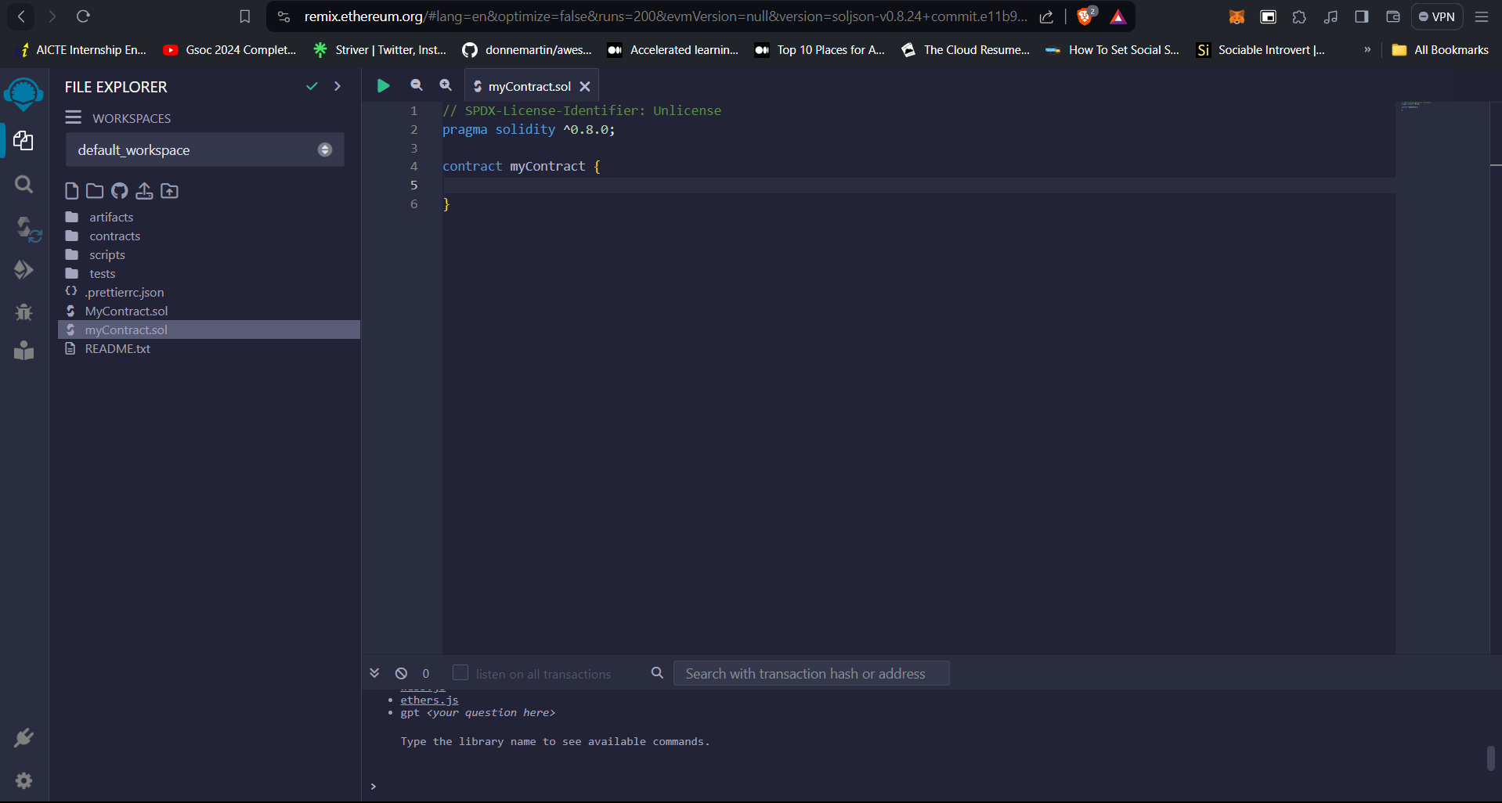

4.3). Basic layout in remixIDE

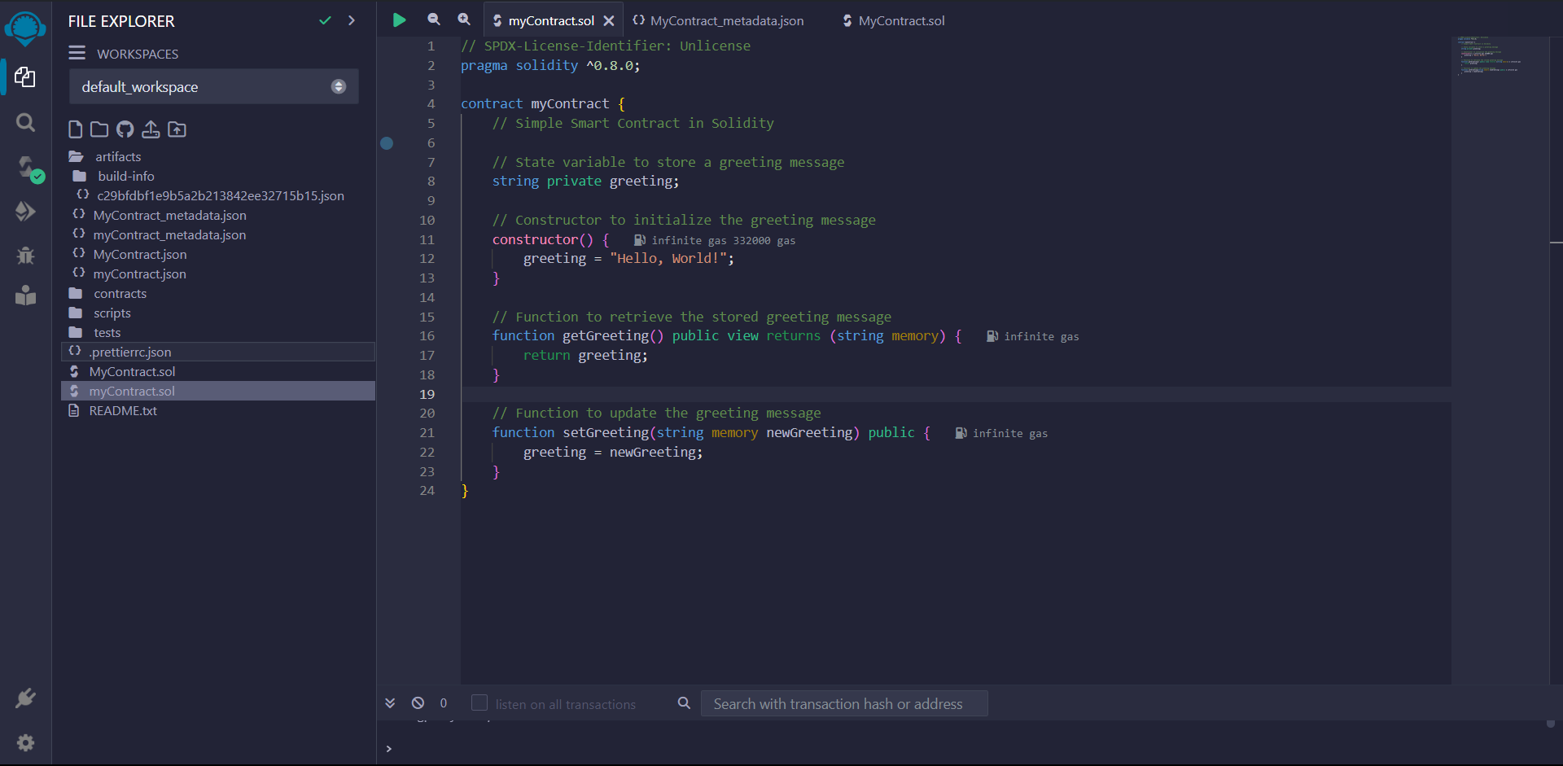

4.4). Sample program in Solidity

**5). FAQs :**

Q1). What are the key features or syntax elements of Solidity that facilitate smart contract development?

* Solidity, a programming language for Ethereum smart contracts, incorporates key features and syntax elements that facilitate smart contract development:
* Contract Definition: Solidity allows developers to define smart contracts using the contract keyword, encapsulating the code and data into a single unit.
* Data Types: It supports various data types such as integers, strings, arrays, and custom structures, providing flexibility in handling different types of data.
* Functions: Developers can define functions within contracts to encapsulate specific operations, enabling modularity and reusability.
* Modifiers: Solidity includes modifiers that can be applied to functions, allowing developers to enforce conditions before or after a function executes.
* Events: Events enable communication between smart contracts and external applications, providing a way to notify external entities about specific occurrences.
* Inheritance: Solidity supports inheritance, allowing developers to create modular and extensible contract structures by inheriting properties and functionalities from other contracts.
* Gas Considerations: Solidity accounts for the cost of execution (gas) in Ethereum transactions, helping developers optimize contracts for efficiency and cost-effectiveness.
* Security Considerations: It includes features like access control, visibility specifiers, and safe arithmetic operations to enhance the security of smart contracts.
* Understanding and leveraging these features is crucial for effective smart contract development on the Ethereum blockchain.

Q2). How does Solidity differ from traditional programming languages, and what challenges might developers face when transitioning to it?

* Solidity differs from traditional programming languages in several ways, posing unique challenges for developers transitioning to it:
* Blockchain Paradigm: Solidity is designed for decentralized, blockchain-based applications. Developers accustomed to centralized architectures may find the decentralized and trustless nature of blockchain challenging.
* Ethereum-Specific: Solidity is Ethereum's native language, tailored for the Ethereum Virtual Machine (EVM). Developers need to grasp Ethereum's concepts, like gas fees, mining, and consensus mechanisms.
* Security Concerns: Blockchain environments are immutable, and smart contracts, once deployed, cannot be altered. Solidity demands a heightened focus on security to prevent vulnerabilities and ensure robust, bug-free code.
* Gas Considerations: Solidity developers need to be mindful of gas costs associated with executing transactions on the Ethereum network. Efficient coding practices are crucial to optimize gas usage.
* Decentralized Data Storage: Traditional databases differ significantly from blockchain's decentralized storage. Solidity developers must adapt to storing data on-chain, ensuring transparency and accessibility.
* No Centralized Authority: In traditional development, there's often a central authority to address issues. In Solidity, decentralized governance and consensus mechanisms govern the network, requiring a shift in mindset.
* Lack of Debugging Tools: Solidity's debugging tools are less mature compared to traditional languages, making it challenging to identify and resolve issues during development.
* Evolutionary Nature: The blockchain space evolves rapidly. Developers need to stay updated on Solidity's features, best practices, and any changes in the Ethereum ecosystem.
* Navigating these differences and challenges requires a commitment to understanding the blockchain paradigm, Ethereum's intricacies, and adopting secure coding practices to build resilient and efficient smart contracts.

Q3). Can you provide an example of a simple smart contract and explain its functionality using Solidity?

// Simple Smart Contract in Solidity

// Contract definition

contract HelloWorld {

// State variable to store a greeting message

string private greeting;

// Constructor to initialize the greeting message

constructor() {

greeting = "Hello, World!";

}

// Function to retrieve the stored greeting message

function getGreeting() public view returns (string memory) {

return greeting;

}

// Function to update the greeting message

function setGreeting(string memory newGreeting) public {

greeting = newGreeting;

}

}

Q4). How does solidity contribute to the creation of decentralized applications (DApps)?

* Solidity, Ethereum's programming language, underpins the creation of decentralized applications (DApps).
* It enables the development of self-executing smart contracts, ensuring trust and transparency in DApps.
* Solidity's code immutability guarantees the integrity and security of decentralized applications.
* The language supports interoperability, token creation, and transparent execution, enhancing overall functionality.
* Solidity facilitates decentralized governance, allowing communities to collectively make decisions.
* It contributes to building secure, transparent, and decentralized applications operating on blockchain networks.

Q5). What is the primary purpose of Solidity in the context of blockchain development?

* The primary purpose of Solidity in the context of blockchain development is to serve as a programming language for creating smart contracts on the Ethereum blockchain.
* Solidity enables developers to define the rules and logic governing these self-executing contracts, which automatically execute when predetermined conditions are met.
* It plays a crucial role in implementing decentralized applications (DApps) and blockchain-based systems by providing the means to encode complex business logic into secure and transparent smart contracts, contributing to the overall functionality and trustworthiness of decentralized ecosystems.

**6). Conclusion :** In summary, the Solidity programming lab offered practical exposure to blockchain development. Hands-on activities coding and deploying smart contracts deepened understanding, highlighting Solidity's pivotal role in crafting secure and transparent decentralized applications.